New Repeater for Ojai
Black Mountain Site
22 April 2026

Wayne, John, Mike, and Jesse loaded the rack containing the new 2 Meter and GMRS repeaters in Mike’s pickup. All the tools and equipment we needed were loaded into John’s pickup. We headed to the top of Black Mountain and opened the building containing the old 2 Meter repeater, sown in Figure 1. The first thing we did was to cut off the old bolts that were left over from the older battery location to make room to install the new rack. We then disconnect the batteries and remove them from the building to give us room to remove the old rack.
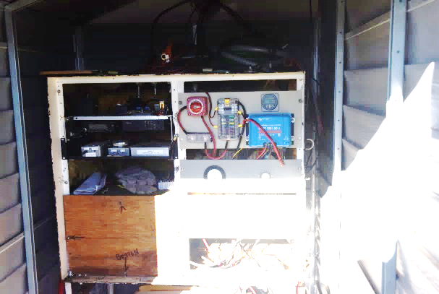

Figure 1. Old 2-meter repeater rack

We temporarily moved the new rack into the building, shown in Figure 2, and marked the new mounting holes that will be used to attach the rack to the floor. We removed the solar charger, RF power meter panels, and the MESH equipment and installed them in the new rack. We then removed the old 2 Meter repeater equipment and the 2 Meter RF cavities and set them aside. The new rack was then moved outside of the building so we could get the old rack out of the building.

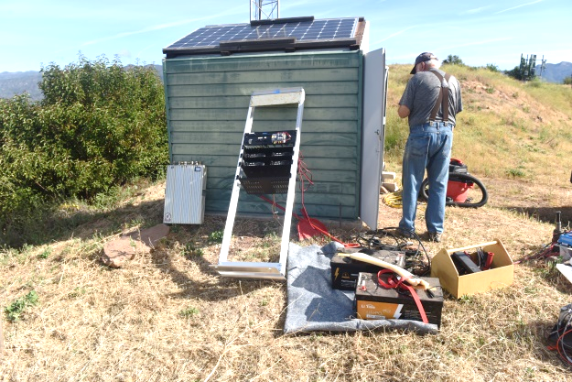
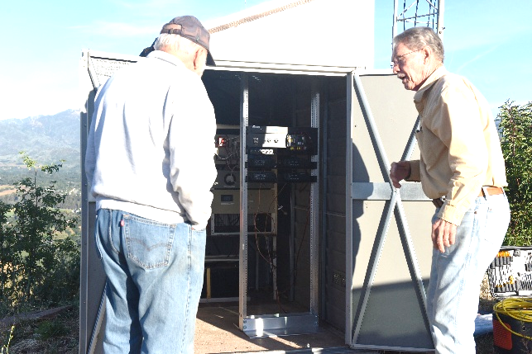

Figure 2. New rack moved into building Figure 3. Equipment moved outside to make
to mark mounting holes. Room for removing the old rack.

We removed the nuts that attached the old rack to the floor and tried to lift the rack off the bolts, but it would not move. Mike had a hydraulic jack that we used to lift the rack and then moved it outside. Figure 4 shoes John working on removing the old rack. We then cut off the old bolts that were in the floor so they would not become a safety hazard. With everything out of the building we vacuumed the floor and cleaned out the cobwebs. Figure 5 shows the cleaned-out building.

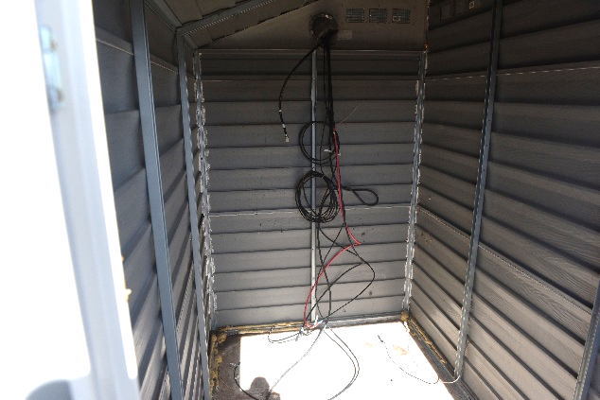
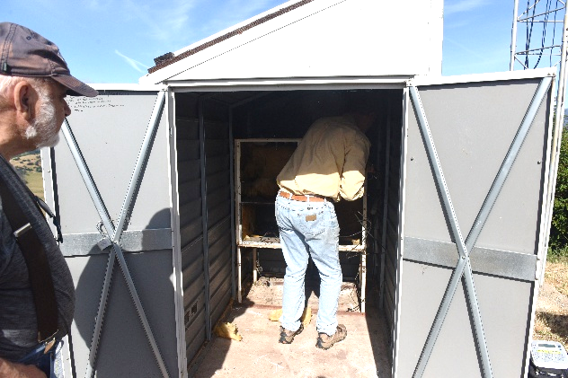

Figure 4. Removing the old rack. Figure 5 The empty building, ready for installing the new equipment.

We reinstalled the batteries and the 2 Meter RF Cavities between the batteries and the wall of the building, shown in Figure 6. We drilled the holes to install the new rack and inserted the lag bolts. The new repeater rack was moved into the building and bolted to the floor. John worked on the power distribution system wiring in the new rack. Wayne set up the MESH system, and I worked on the RF cables installation for the 2 Meter and GMRS repeaters. Mike replaced the tower leg bolts.
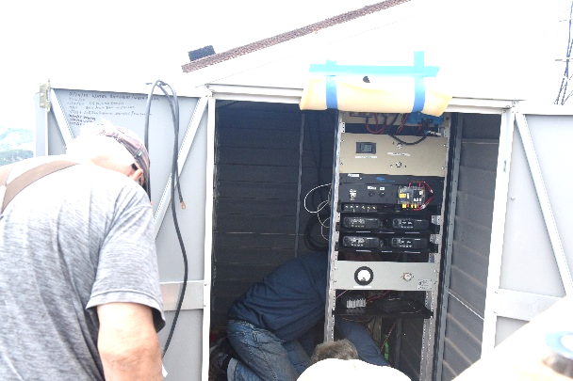
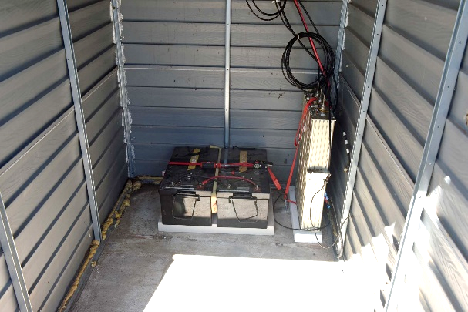

Figure 6. Battery and 2 meter cavity Figure 7. New rack installation.
Installation.

We applied power to the system, and both repeaters were operating along with the MESH systems. Figure 8 shows the new repeater rack installed in the building. With both repeaters in the receive mode and the MESH operating we were drawing about 2.7 amps. With the 2-meter in transmit mode we drew 7.2 amps and with both the 2 Meter and the GMRS transmitters on we drew 13.3 amps. So, most of the time we are only drawing 2.7 amps from the batteries. With the two 400 amp hour batteries that should give us a little over a week operating time on just the batteries in case we lose the solar charger.
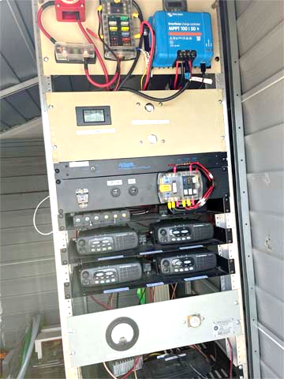

Figure 8. New repeater rack installed in the building.

On 9 May 2026 John, Mike, and I made another trip to the repeater site to replace the power cables and the solar panel and wiring. We also planned to work on RF cabling. We turned off the power to the rack and disconnected the batteries and solar power. John and Mike then removed the old solar panel off the roof, Figure 9, and replaced it with the new panel that had a little higher output, figure 10.
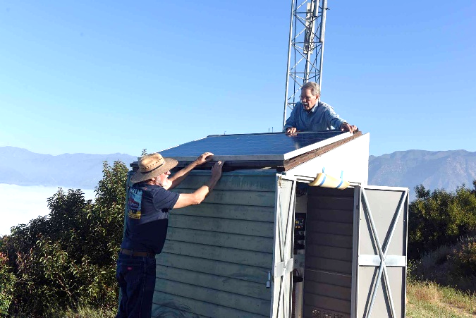
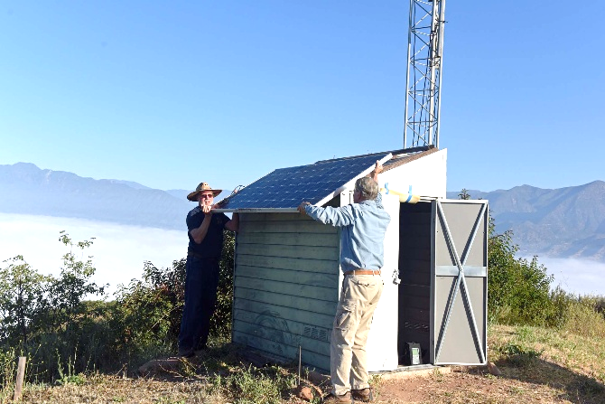

Figure 9. Removal of the old solar Panel. Figure 10. Installation of new solar panel.

After the new solar panel was installed, Mike and John built the new solar panel and battery power cabling. I worked on the rewiring of the RF cables which included replacing some of the short cable runs with RG-8X instead of the RE-213. Figures 11 and 12 show the assembly of the new power cables.
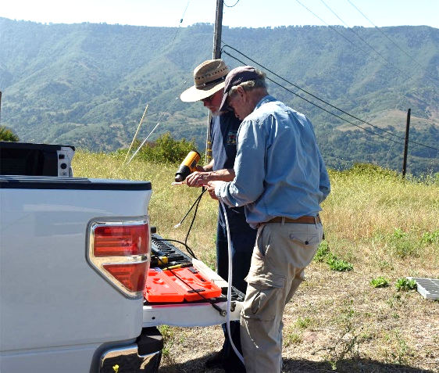
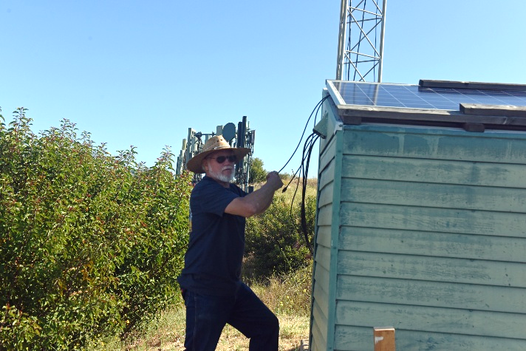

Figure 11. Mike works on the new solar panel Figure 12. John & Mike working on
Cables. assembly of connectors for power
cables.

The new power cables were installed in the building and connected to the new repeater rack. Figure 13 shows the routing of the power and RF cables in the building and Figure 14 shows the repeater rack with the new power cables installed.
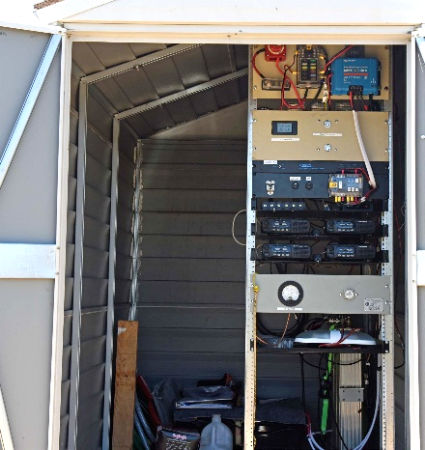
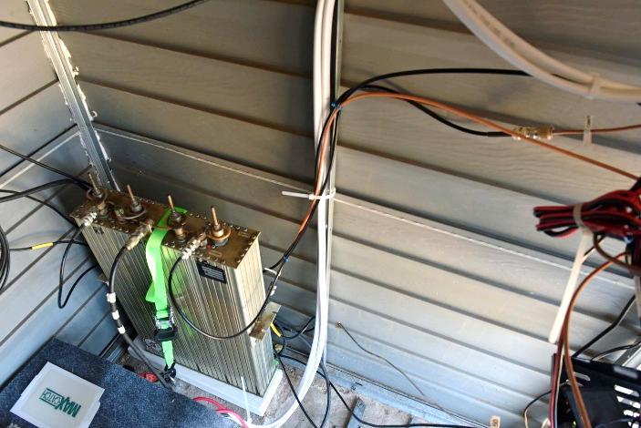

Figure 13. New power and RF cable installation. Figure 14. Repeater rack with new power
Cables installed.

We did not have a GMRS radio with us, so we were not able to evaluate the GMRS repeater before leaving the mountain. Once Mike arrived home, he noticed he could not access the GMRS repeater. I tried using the remote-control feature to turn off and on the GMRS repeater and received the reply that GMRS was off and then on. So, the control link was working but the repeater was not. I had time to go back to the site on 10 May to troubleshoot the problem. I checked all the power and RF cables, and they were all OK and the radios were all powered on. I could not find a problem, so I started to close the doors to the building when I spotted a DB-9 connector lying on one of the shelves. There should not have been a DB-9 cables lying around. I looked at the connector, and it was labeled GMRS controller. When I looked at the repeater controller there was a connector libeled GMRS controller, so I attached the cable and the GMRS repeater was operational. Figure 15 shows the repeater controller with the missing connector. The connector was probably knocked loose during the power cable routing.
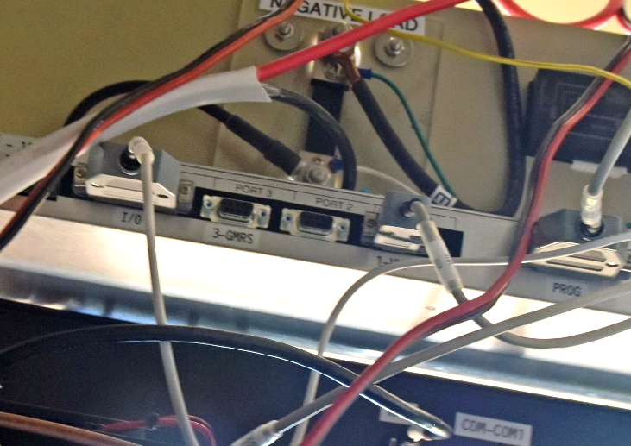

Figure 15. Repeater controller with missing connector.
During this trip I made some SWR measurements on the 2-meter antenna and the GMRS antenna. I also took a measurement at the transmiter input to the 2-meter cavity. These measurements are shown in Figures 16, 17, and 18. As you can see in the photos, I forgot to move the cursor over to our frequency so the SWR reading on the top of the screen is a little miss leading. The GMRS plot shows we are at the edge of the antenna pass band, so we should probably replace the 440 MHz antenna with a GMRS antenna
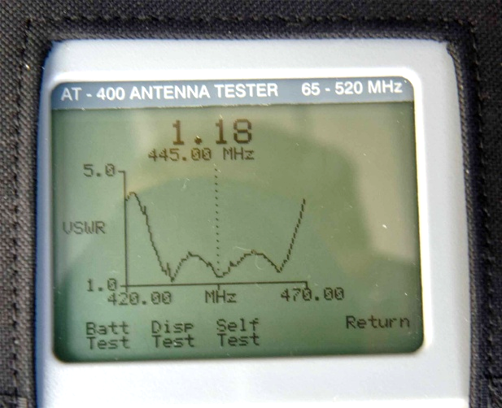
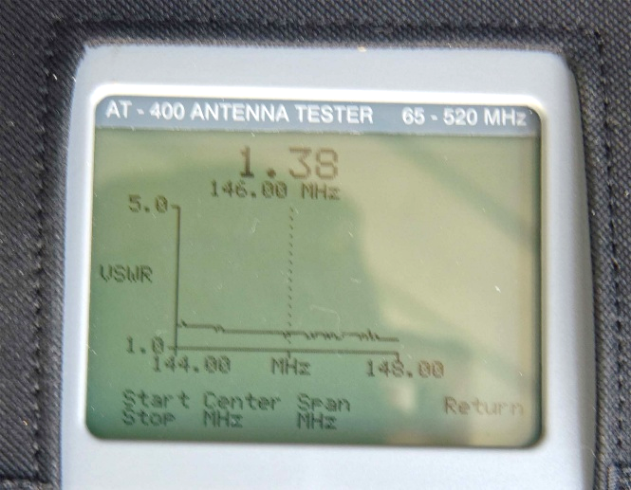

Figure 16. The chart shows an SWR of 1.8 Figure 17. The chart shows an SWR of 1.8
for 144.8 MHz. for the GMRS frequency 462.625 MHz.

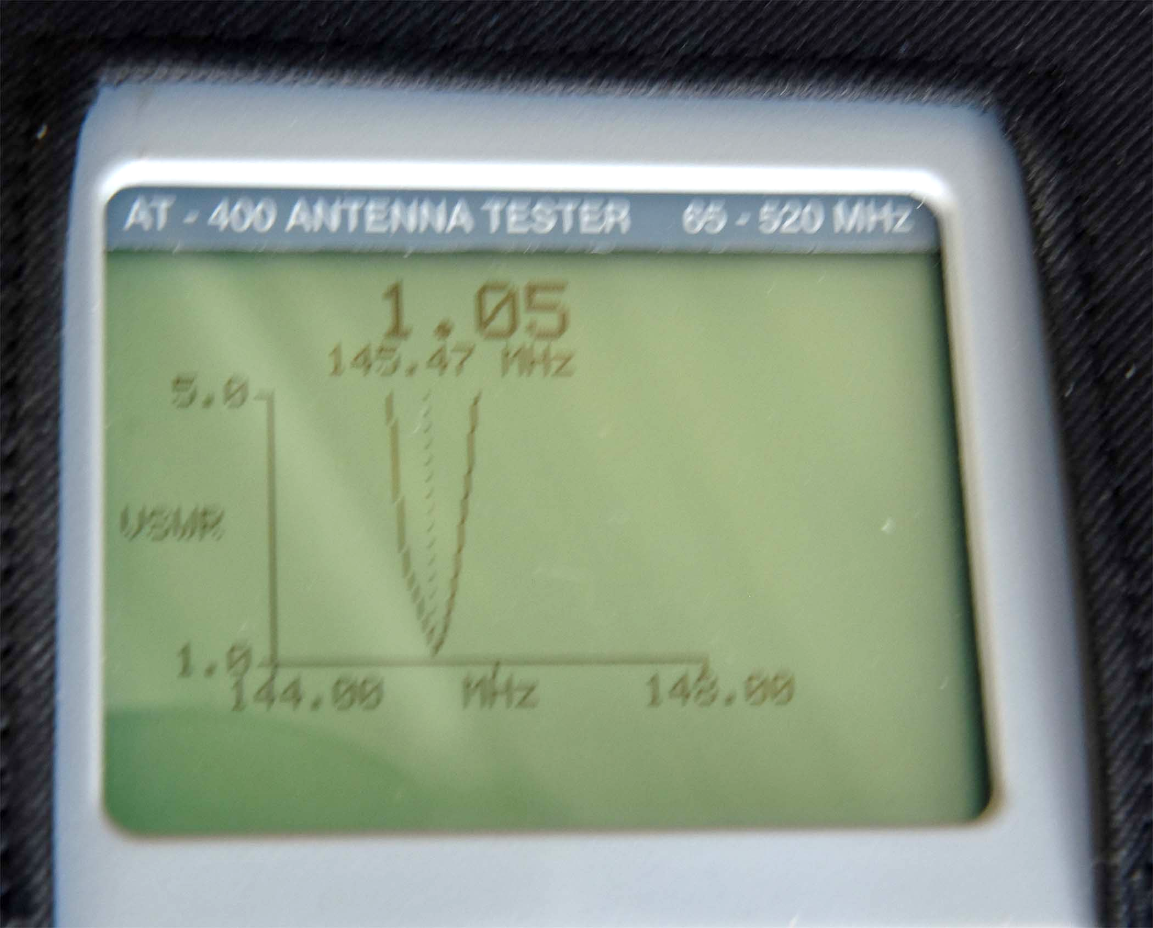

Figure 18. Shows an SWR of 1.05 for the transmit side of the 2-meter
cavity for our 2-meter transmit frequency of 145.4 MHz.

